PIZZA SALES SQL QUERIES
- KPI

- Total Sum:
SELECT SUM(total_price) AS Total_Revenue from pizza_sales;

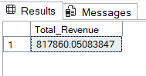

- Average Order Value:

SELECT SUM(total_price)/COUNT(DISTINCT(order_id)) AS Average_Order_Value from pizza_sales;
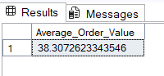

- Total Pizzas Sold:
SELECT SUM(quantity) AS Total_Prod_sold from pizza_sales;
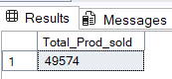

- Total Orders:
SELECT SUM(DISTINCT(order_id)) AS Total_Orders from pizza_sales;
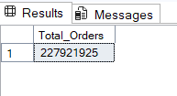

5) Average Pizza Per Order:
SELECT CAST(CAST(SUM(quantity) AS DECIMAL (10,2))/CAST(COUNT(DISTINCT order_id) AS DECIMAL (10,2)) AS DECIMAL(10,2)) AS Avg_Pizza_per_Order from pizza_sales;

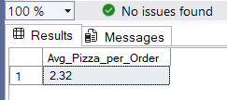

- CHART

1) Daily Trends For Total Order:
SELECT DATENAME(DW, order_date) AS Order_day,
COUNT(DISTINCT order_id) AS Total_Orders from pizza_sales
GROUP BY DATENAME(DW, order_date);
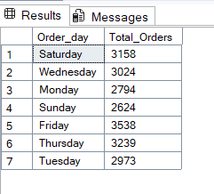

- Monthly Trend for Total Orders:
SELECT DATENAME(MONTH, order_date) AS Month_Name,
COUNT(DISTINCT order_id) AS Total_Orders from pizza_sales
GROUP BY DATENAME(MONTH, order_date)
ORDER BY Total_Orders DESC;

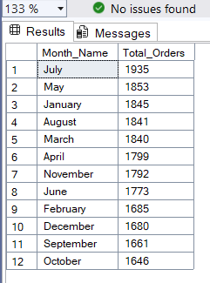

- Percentage Of Sales In Pizza Category:

SELECT DATENAME(DW, order_date) As order_day, COUNT(DISTINCT order_id) AS total_orders FROM pizza_sales
WHERE MONTH(order_date) = 1 GROUP BY DATENAME(DW, order_date)

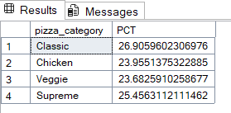

NOTE

If you want to apply the Month, Quarter, Week filters to the above queries you can use WHERE clause. Follow some of below examples

SELECT DATENAME(DW, order_date) As order_day, COUNT(DISTINCT order_id) AS total_orders FROM pizza_sales
WHERE MONTH(order_date) = 1 GROUP BY DATENAME(DW, order_date)

* Here MONTH(order_date) = 1 indicates that the output is for the month of 4 indicates output for month of April. January- MONTH(order date)

SELECT DATENAME(DW, order_date) As order_day, COUNT(DISTINCT order_id) AS total_orders FROM pizza_sales
WHERE DATEPART(QUARTER, order_date) = 1 GROUP BY DATENAME(DW, order_date)

* Here DATEPART(QUARTER, order_date) = 1 indicates that the output is for the Quarter 1. MONTH(order_date) 3 indicates output for Quarter 3.

- Percentage Of Sales By Pizza Size:

SELECT pizza_size,CAST(SUM(total_price) AS DECIMAL(10,2)) AS Total_Sales , CAST(SUM(total_price) * 100/(SELECT SUM(total_price) from pizza_sales WHERE DATEPART(QUARTER, order_date) = 1) AS DECIMAL(10,2)) AS PCT from pizza_sales WHERE DATEPART(QUARTER, order_date) = 1
GROUP BY pizza_size
ORDER By PCT DESC

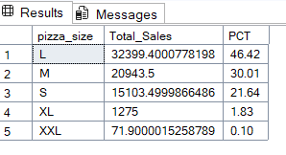

- TOP 5 Best Selling Pizza:

SELECT TOP 5 pizza_name, CAST(SUM(total_price) AS DECIMAL (10,2)) AS Total_Revenue from pizza_sales GROUP BY pizza_name ORDER BY Total_Revenue DESC

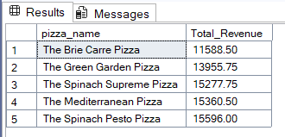

- TOP 5 Worst Selling Pizza:

SELECT TOP 5 pizza_name, CAST(SUM(total_price) AS DECIMAL (10,2)) AS Total_Revenue from pizza_sales GROUP BY pizza_name ORDER BY Total_Revenue

- TOP 5 Best Pizza BY Quantity:

SELECT TOP 5 pizza_name, SUM(quantity) AS Quantity from pizza_sales GROUP BY pizza_name ORDER BY Quantity DESC

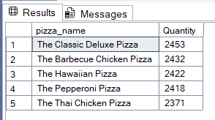

- TOP 5 Worst Pizza BY Quantity:

SELECT TOP 5 pizza_name, SUM(quantity) AS Quantity from pizza_sales GROUP BY pizza_name ORDER BY Quantity ASC

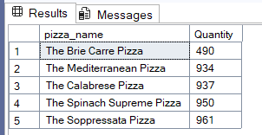

- TOP 5 Best Pizza BY Total Orders:

SELECT TOP 5 pizza_name, COUNT(DISTINCT order_id) AS Total_Orders from pizza_sales GROUP BY pizza_name ORDER BY Total_Orders DESC

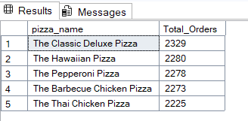

- TOP 5 Best Pizza BY Total Orders:

SELECT TOP 5 pizza_name, COUNT(DISTINCT order_id) AS Total_Orders from pizza_sales GROUP BY pizza_name ORDER BY Total_Orders

